Project Design Phase-II

Data Flow Diagram & User Stories

|  |  |
| --- | --- |
| Date | 10 October 2022 |
| Team ID | PNT2022TMID07659 |
| Project Name | Project – Fertilizer recommendation system for disease prediction |
| Maximum Marks | 4 Marks |

# Data Flow Diagrams:

A Data Flow Diagram (DFD) is a traditional visual representation of the information flows within a system. A neat and clear DFD can depict the right amount of the system requirement graphically. It shows how data enters and leaves the system, what changes the information, and where data is stored.

* Collect images of different leaves organized into subdirectories based on their respective names as shown in the project structure.
* Image data augmentation is a technique that can be used to artificially expand the size of a training dataset by creating modified versions of images in the dataset.
* Import the model building Libraries
* Initializing the model
* Adding CNN Layers
* Adding Hidden Layer
* Adding Output Layer
* Configure the Learning Process
* Training and testing the model
* Saving the model

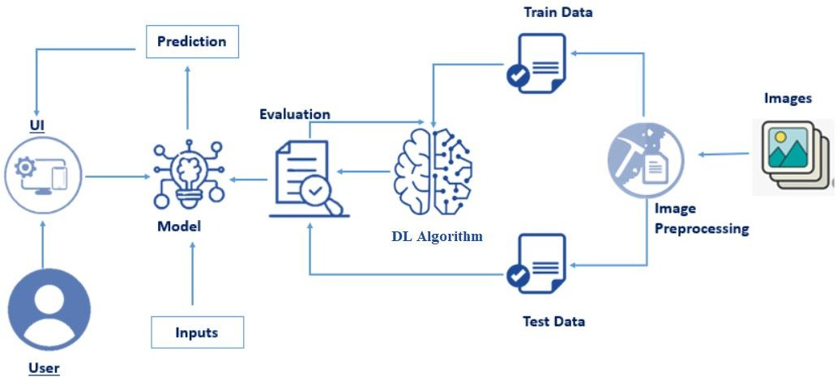

# User Stories

Use the below template to list all the user stories for the product.

|  |  |  |  |  |  |  |
| --- | --- | --- | --- | --- | --- | --- |
| **User Type** | **Functional Requirement**  **(Epic)** | **User Story Number** | **User Story / Task** | **Acceptance criteria** | **Priority** | **Release** |
| Customer (Mobile user) | Registration | USN-1 | As a user, I can register for the application by entering my email, password, and confirming my password. | I can access my account / dashboard | High | Sprint-1 |
|  |  | USN-2 | As a user, I will receive confirmation email once I have registered for the application | I can receive confirmation email & click confirm | High | Sprint-1 |
|  |  | USN-3 | As a user, I can register for the application through Facebook | I can register & access the dashboard with Facebook  Login | Low | Sprint-2 |
|  |  | USN-4 | As a user, I can register for the application through Gmail |  | Medium | Sprint-1 |

|  |  |  |  |  |  |  |
| --- | --- | --- | --- | --- | --- | --- |
| **User Type** | **Functional**  **Requirement (Epic)** | **User Story Number** | **User Story / Task** | **Acceptance criteria** | **Priority** | **Release** |
|  | Login | USN-5 | As a user, I can log into the application by entering email & password |  | High | Sprint-1 |
|  | Dashboard |  |  |  |  |  |
| Customer (Web user) |  |  |  |  |  |  |
| Customer Care Executive |  |  |  |  |  |  |
| Administrator |  |  |  |  |  |  |
|  |  |  |  |  |  |  |
|  |  |  |  |  |  |  |
|  |  |  |  |  |  |  |